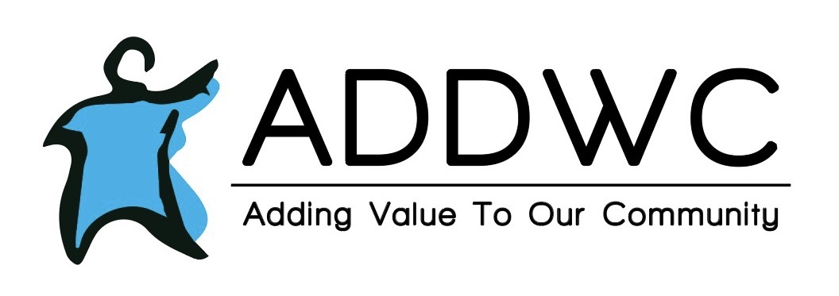Sept. 2021

|  |
| --- |
| **LIFE SKILLS HAPPENINGS**  Life skills will continue to do community work for other organizations, such as the dream center. Life skills is planning a trip to the zoo in August as well as making a quilt with pictures of the clients on it. |
|  | |
|  | |

Tap here to add a caption

**RESIDENTIAL**

JT's dad is cooking food for a cookout for the guys to eat and celebrate on Labor Day weekend at Court St. We also have some birthdays we will be celebrating at each house. Staff appreciation week will also take place in September.

**RECYCLING NEWS**

* ADDWC processed 59.31 tons of material in July, which brings our YTD total to 300.00 tons.
* The 7th Annual ADDWC Going Green Golf Outing is only 4 weeks away! We are seeking teams, donations, and sponsorships. For more information go to [www.addwc.org/going-green-golf](http://www.addwc.org/going-green-golf) or contact Roger Crow at [rcrow@addwc.org](mailto:rcrow@addwc.org)

**September Birthdays**

**Derek J. 09/06**

**Jennifer B. 09/11**

**Greg S. 09/23**

**Greg I. 09/24**

* We are having a $1,000.00 cash drawing at the golf outing on August 29th. Need not be present to win. Tickets are for sale now, and may be purchased at 200 Moody St. Eureka or through our PayPal by visiting [www.addwc.org/going-green](http://www.addwc.org/going-green) The cost is $20.00 each, or 6 for $100.00

  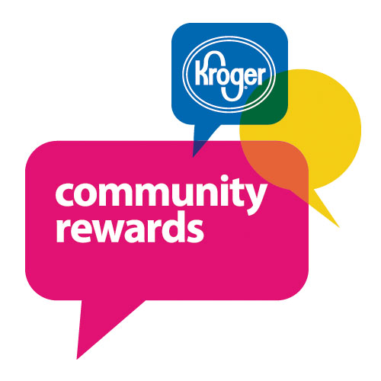 

# MAURIES SUGAR SHOPPE

|  |
| --- |
|  |

**Contact Us**

Mauries Sugar Shoppe

116 N Main Street

Eureka, IL 61530

(309) 304-1135

**Hours:**

Tuesday-Friday 11:00-5:00

Saturday -11:00-4:00

**Facebook:**

Mauries Facebook

Maurie's is picking up steam!  We are seeing more and more people coming into the store and enjoying our environment!  We share the ADDWC mission as often as we can to continue the bridge between our individuals and the community.  We are so blessed to live and work in such a supportive, generous community.

Caramel apple season is just around the corner and we plan to start our sales Labor Day weekend at both Maurie's and Leaves 'n Beans in Pekin, Morton and Peoria Heights.  We are excited about this new venture and the jobs it is creating for our individuals.  We continue to bring folks in as much as possible.

Stop by sometime and see some of our new products.  Life Skills is making peanut butter Dog Treats for us to sell and they are going like hotcakes!  One of our individuals suggested Scotch-a-roos and brought in a recipe so we are now selling those.  We have also added bear claws, pretzel buckeyes, chocolate covered maraschino cherries and gummi kabobs!  We have a tremendous inventory of homemade goodies that make for great gifts and rewards!

In addition to our new treats, we continue to get artwork from Life Skills to display in the store.  Here are some pictures to enjoy!

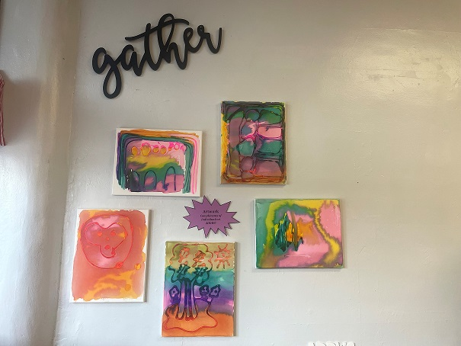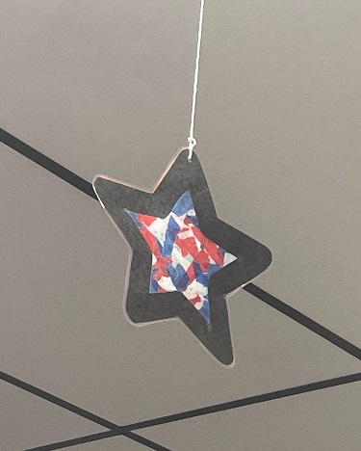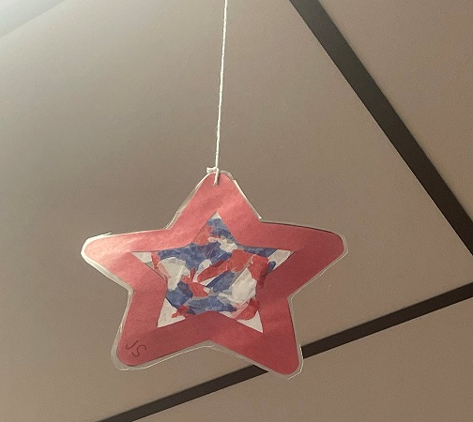

|  |  |
| --- | --- |
| ADDWC Closed Days  September 6-(Labor Day)  September 29th-(Golf outing)  Contact Us  ADDWC  200 Moody Street  Eureka, IL 61530  (309)467-3015  [www.addwc.org](http://www.addwc.org)  **Facebook:**  ADDWC Facebook | **Employment Opportunities**  Residential DSP - assisting individuals with intellectual disabilities with daily living activities in a residential setting.  2nd and 3rd shifts available  Paid training provided; $15.15/hr. after 90 day probation period. |
|  |  |