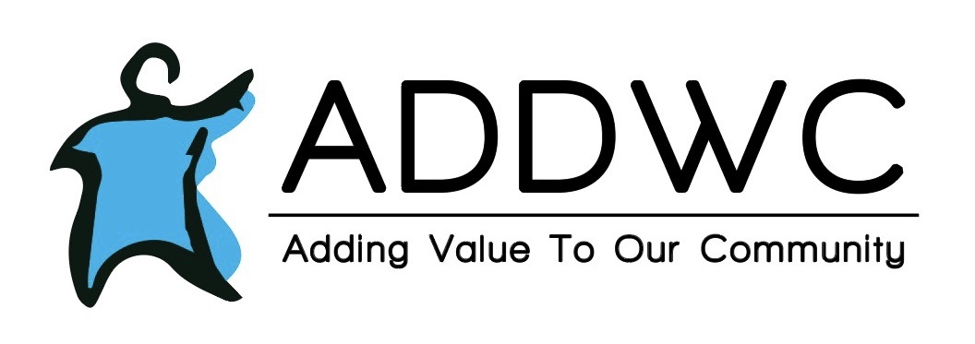

**January 2022**

**LIFE SKILLS HAPPENING**

Clients and staff teamed up and did a door decorating contest, each team drew the name of a Christmas movie and had to decorate the door to reflect the movie. In January, Life skills is going to be learning about healthy eating and exercise. They will also start doing one-on-one with the clients.



**RESIDENTIAL**

*Each CILA celebrated Christmas and opened gifts. Congrats to our Parkview CILA for winning the door decorating contest!!

* Everyone enjoyed seeing the festival of lights, and are now looking forward to watching the New year’s eve countdown on TV.

*Clients have been asking, and patiently waiting on when we will have snow for Winter.





**Ellen A. 1/24/22**

|  |
| --- |
| Alex Kennel-10/08  Brent Hillman-10/14  Deb Crawford-10/20  Bryan Zaeske-10/25  Kyle Kamm-10/31  **HAPPY BIRTHDAY!!** |
|  | |
|  | |

Tap here to add a caption\\

  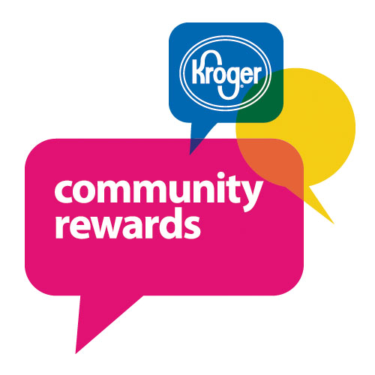 

# **MAURIES SUGAR SHOPPE**

|  |
| --- |
|  |

Contact Us

Mauries Sugar Shoppe

116 N Main Street

Eureka, IL 61530

(309) 304-1135

**Hours:**

Tuesday-Friday 11:00-5:00

Saturday -11:00-4:00

**Facebook:**

Mauries Facebook

December was an OUTSTANDING month for Maurie's Sugar Shoppe!  Our clients were able to work most weeks this month cleaning and helping make popcorn, Puppy Chow, Scotch-a-Roos, and Party Cookies.  We are fortunate to have their assistance as December is officially the month with the highest sales since we opened!  We had so many special orders it was tough keeping up with them, but our team worked a lot of hours to fill all the orders making special treats for many families and friends.  We even had a couple doctors order special treats for their employees!  We look forward to a little slow down but will pick back up quickly with Valentine's Day.  Make sure to order your Chocolate Covered Strawberries before February 12th as we will have limited quantities to purchase that day.

We were invited by the Eureka Events committee to serve Christmas Pretzel Rods and Hot Cocoa at the tree lighting!  What a wonderful event with many compliments on our treats.  We are lucky to be in such a supportive community.

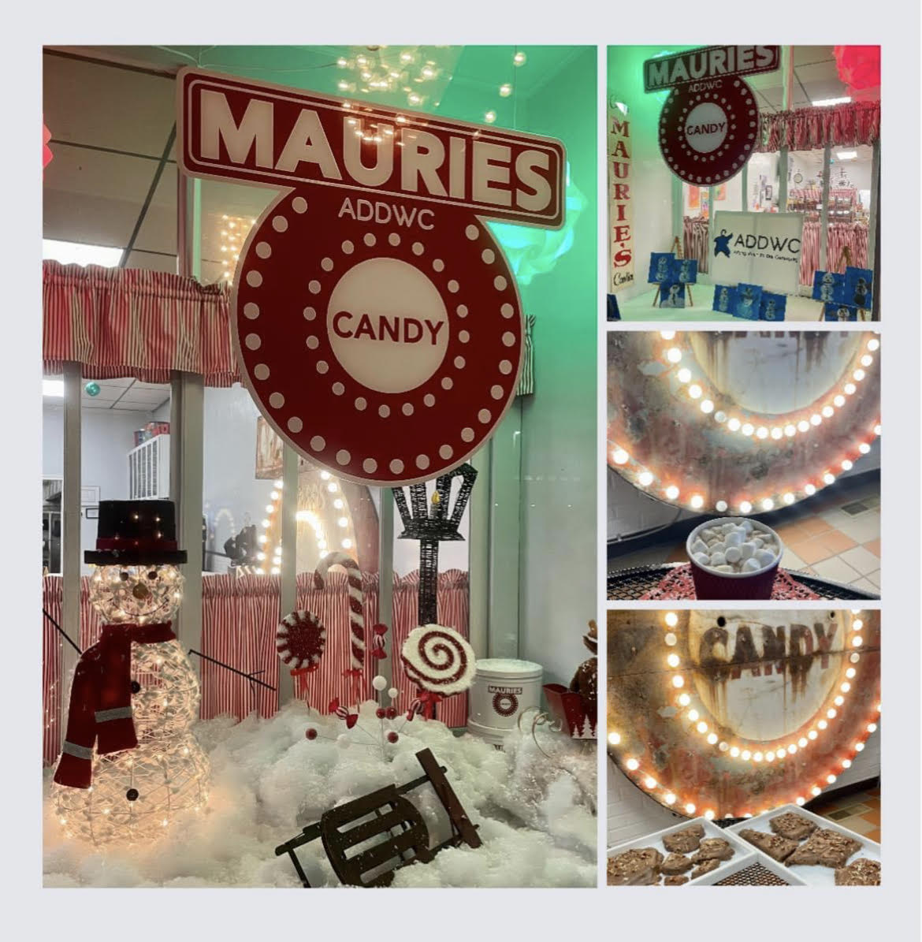

**RECYCLING NEWS**

* ADDWC processed 15.93 tons of material in November, which brings our YTD total to 458.20 tons. We remain consistent, processing around 500 tons (1,000,000 pounds) annually!
* Community Day Service remains closed until Monday, January 3rd 2022. Our recycling drop site remains open 24 hours; however, material won’t be processed between December 31st and January 2nd. Therefore, we are reminding businesses to refrain from bringing large amounts of material between these dates in order to allow room for the residential material that will be brought in.
* ADDWC would like to wish you all a very safe and happy new year!

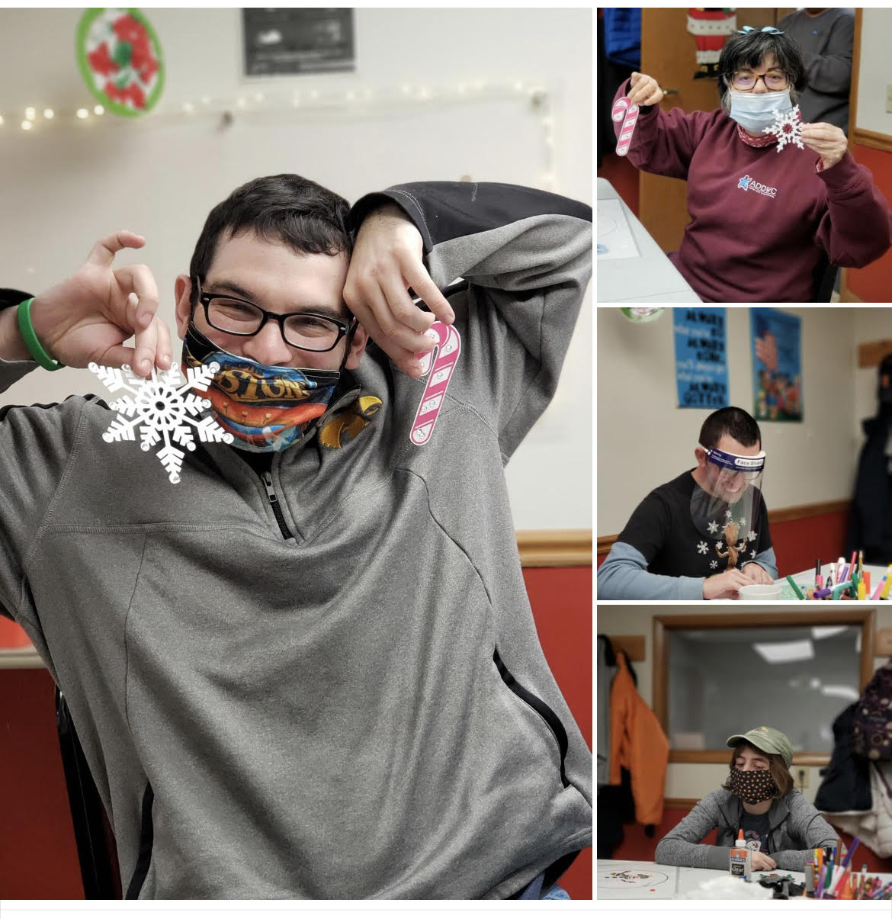 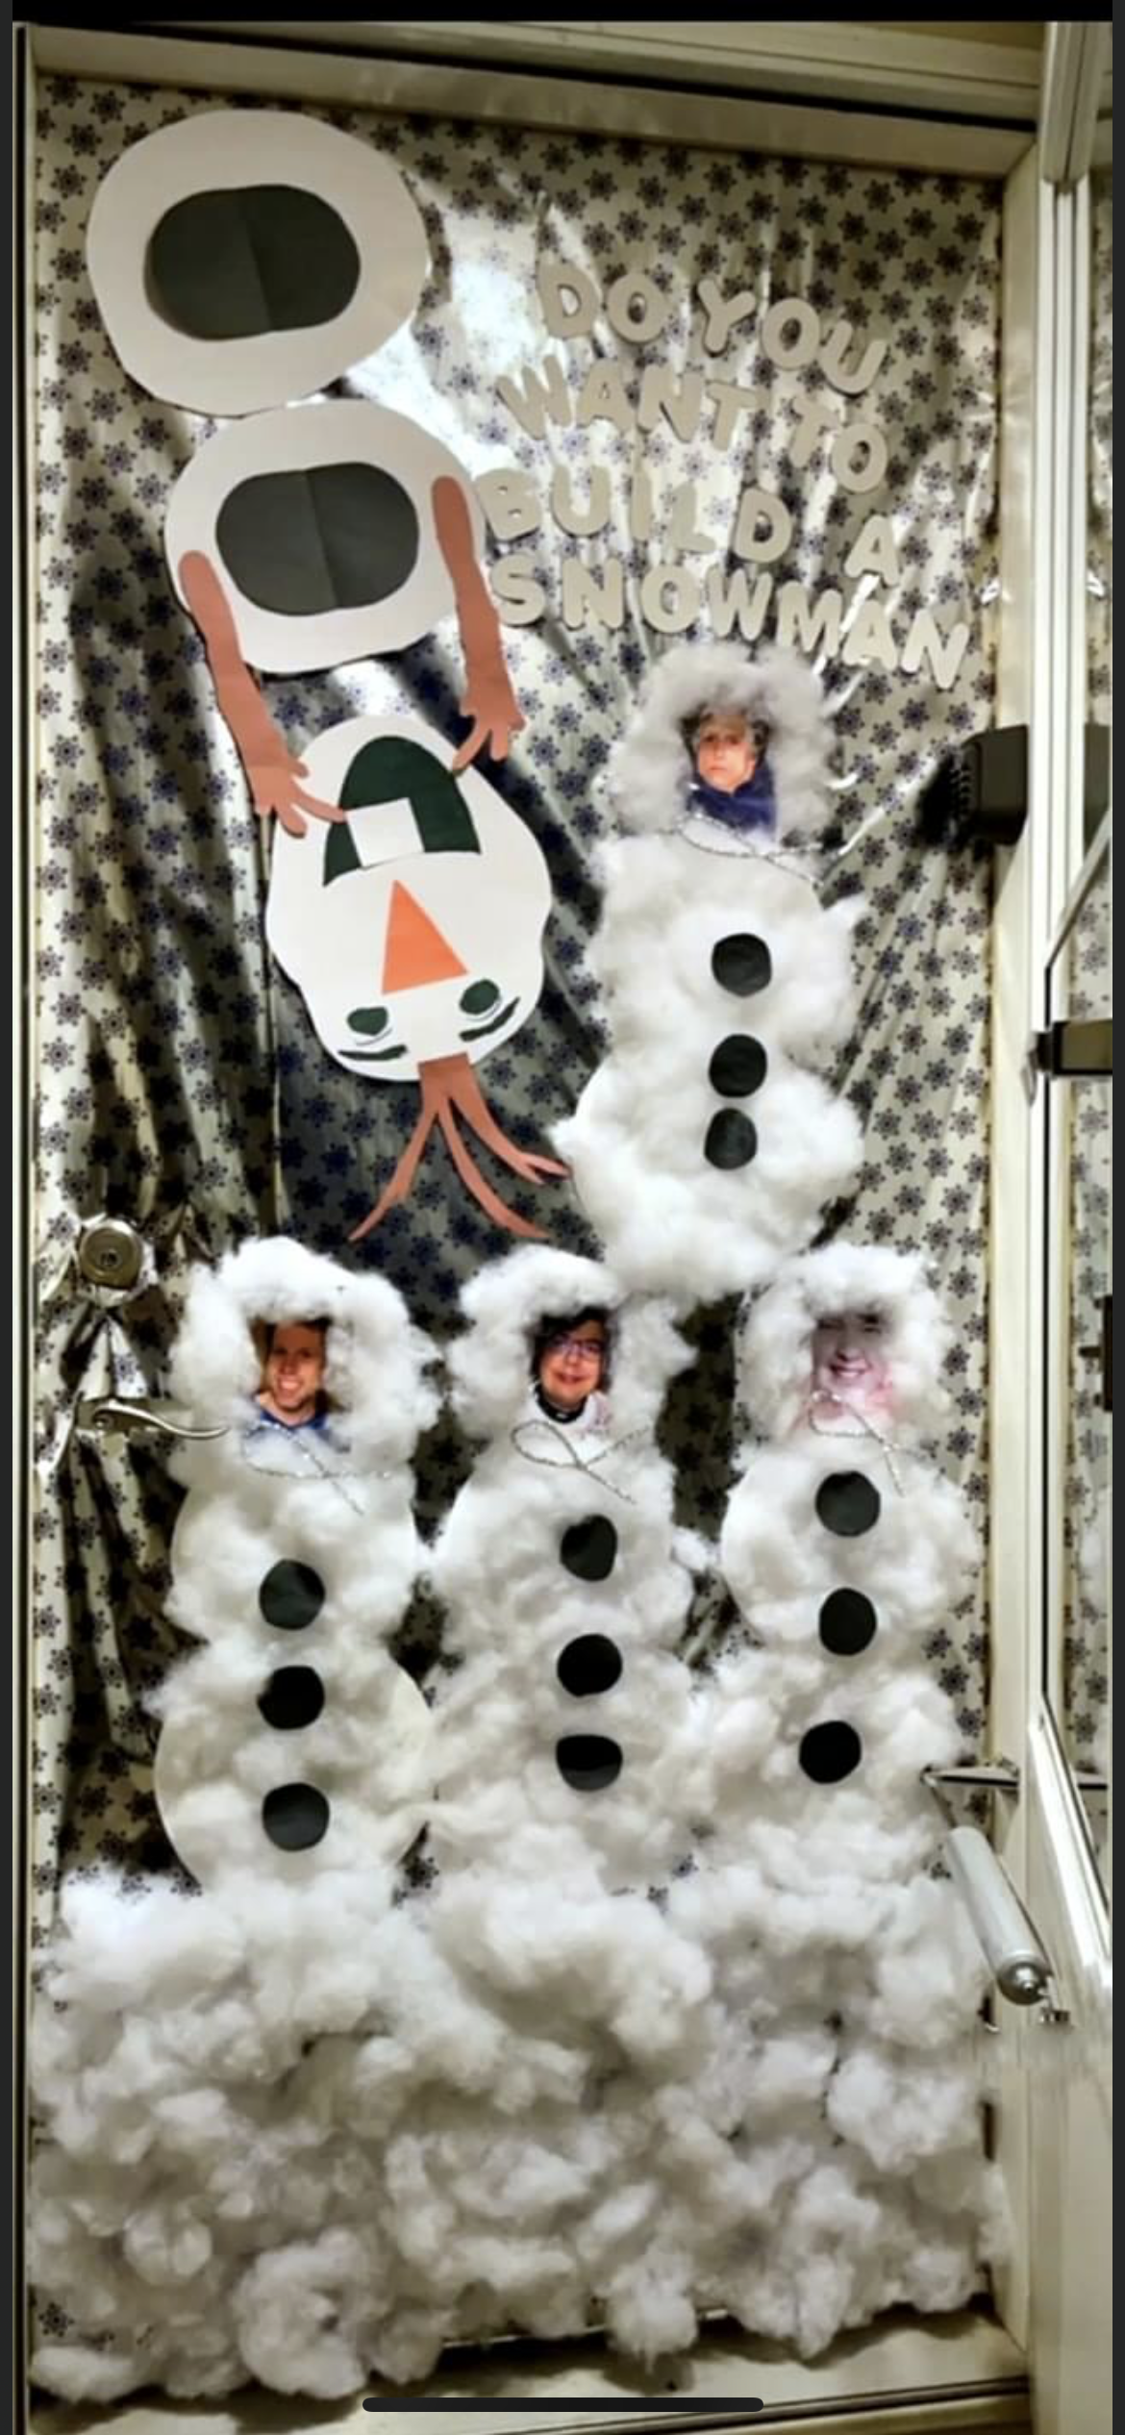

|  |  |
| --- | --- |
| ADDWC Closed Days  January 17th  ________________________________  Contact Us  ADDWC  200 Moody Street  Eureka, IL 61530  (309)467-3015  [www.addwc.org](http://www.addwc.org)  **Facebook:**  ADDWC Facebook | **Employment Opportunities**  Residential DSP - assisting individuals with intellectual disabilities with daily living activities in a residential setting.  2nd and 3rd shifts available  Paid training provided; $15.15(2nd shift), $16.15(3rd shift) after 90-day probation period. |
|  |  |