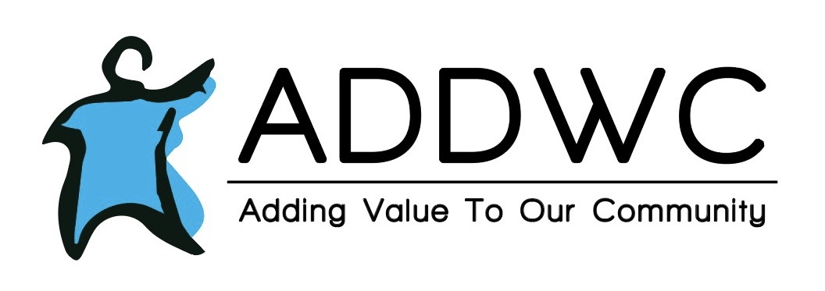Aug. 2021

|  |
| --- |
| **LIFE SKILLS HAPPENINGS**  Life skills is planning a spirit week in August with different themes for each day. One day of spirit week will be an animal day and on that day they will be taking a field trip to the Farm Park.  ****************** |
|  | |
|  | |

Tap here to add a caption

**RESIDENTIAL**

Our residential clients have been taking more trips to go shopping, as well as spending more time outside. Coming up in August they will be planning a trip to go bowling.

**RECYCLING NEWS**

* ADDWC processed 33.08 tons of material in June, which brings our YTD total to 240.54 tons.
* Preparations for the 7th Annual ADDWC Going Green Golf Outing is in full swing! We are actively seeking teams, donations, and sponsorships. These can be paid via PayPal. For more information go to [www.addwc.org/going-green-golf](http://www.addwc.org/going-green-golf) or contact Roger Crow at [rcrow@addwc.org](mailto:rcrow@addwc.org)

**August Birthdays**

Rebekah Z- 8/1

Lisa H-8/10

Derek P-8/28

Dorinda W-8/29

* We are also seeking gift certificates to various places for hole prizes and raffle prizes.
* We are having a $1,000.00 cash drawing at the golf outing on August 29th. Need not be present to win. Tickets are for sale now, and may be purchased at 200 Moody St. Eureka or through our PayPal by visiting [www.addwc.org/going-green](http://www.addwc.org/going-green)-golf the cost is $20.00 each, or 6 for $100.00.

  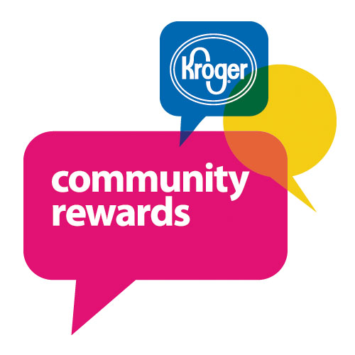 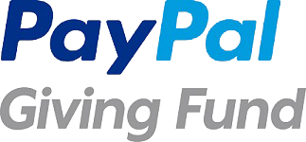

# MAURIES SUGAR SHOPPE

|  |
| --- |
|  |

**Contact Us**

Mauries Sugar Shoppe

116 N Main Street

Eureka, IL 61530

(309) 304-1135

**Hours:**

Tuesday-Friday 11:00-5:00

Saturday -11:00-4:00

**Facebook:**

Mauries Facebook

Maurie's Sugar Shoppe will be selling limited products at all three Leaves 'n Beans locations (Pekin, Morton and Peoria Heights) starting early fall with the caramel apple kick off!  We couldn't be more excited than to partner with James at Leaves 'n Beans.  This fulfills our promise upon purchasing Maurie's of having a presence in Pekin!

Maurie's hosted two field trips for different age groups from the Eureka Library.  The kiddos not only learned about Maurie's, but learned about our mission serving ADDWC.  They had many excellent questions!  We look forward to partnering with the library to host more field trips with folks of all ages including residents from local retirement residences.

We are gearing up for caramel apple season hoping to exceed last year's sales!  Make sure to keep up with us on Facebook at

<https://www.facebook.com/mauriessugarshoppe/> for specials and announcements.

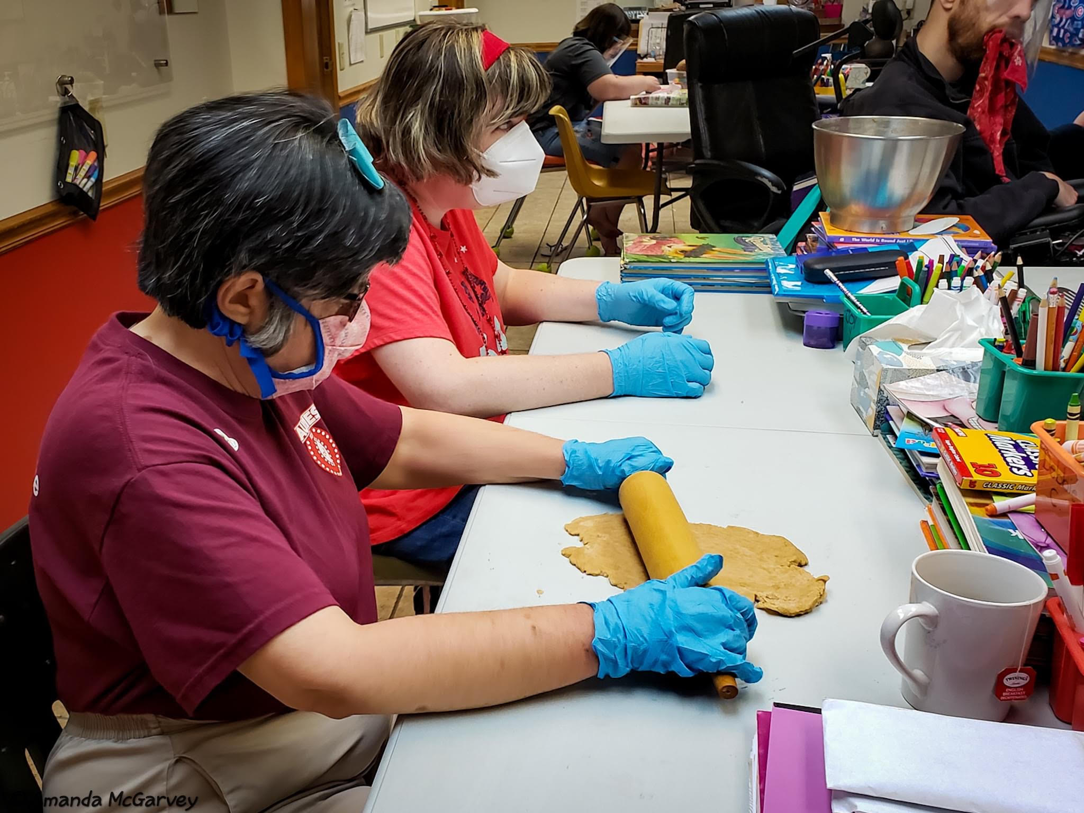

 .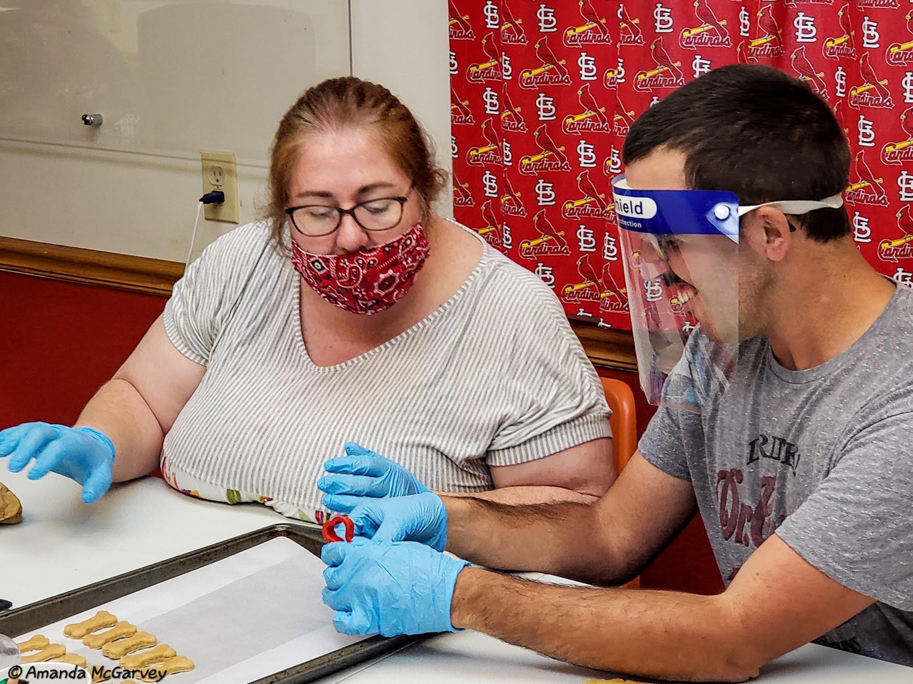

|  |  |
| --- | --- |
| ADDWC Closed Days  No Closed Days in August  ________________________________  Contact Us  ADDWC  200 Moody Street  Eureka, IL 61530  (309)467-3015  [www.addwc.org](http://www.addwc.org)  **Facebook:**  ADDWC Facebook | **Employment Opportunities**  Residential DSP - assisting individuals with intellectual disabilities with daily living activities in a residential setting.  2nd and 3rd shifts available  Paid training provided; $15.15/hr. after 90 day probation period. |
|  |  |

Spotlights

**Employee**: This month we would like to spotlight **Amanda McGarvey.**

Amanda has been with ADDWC going on 3 months now. She works mostly at Moody. In the past, Amanda has worked as a case manager for adults with mental illness. Prior to that she worked as a medical assistant, patient care tech, and birth certificate clerk at OSF. She has also worked in several group homes, and as a CNA in nursing homes, assisted living and Hospice care.

We asked Amanda... “What made you choose the human services field?” “I have always had a desire to help people. In 2012, I lost my Mom to suicide which greatly changed my perspective. I wanted to be a part of something that allowed the opportunity to bring hope and happiness to those I serve at a deeper level. I went back to school and got my Bachelors in Social work. I believe that the human services field allows the possibility to significantly impact individuals in a way that allows them to live their lives to their highest potential.”

When Amanda isn’t at ADDWC she enjoys photography, painting, writing, crafts, hiking and traveling. She also loves music and spending time with her two dogs Jovi and Ezra.

**Supervisor comments:**   
Amanda has done a great job getting acclimated to our agency and clients in a very short time. Her approach to our programs has been natural and refreshing. Congrats and thank you Amanda for your hard work and dedication to our mission statement.

**Client:** This month we would like to spotlight **Rebekah Zobrist.**

Rebekah has worked at ADDWC for 4 years. Her job at ADDWC is bailing and helping bake goodies at Mauries. Rebekah states her favorite thing about ADDWC is Mauries and the people she works with. Rebekah says the people she works with are some of the most important people in her life. When she isn’t working she enjoys baking in her free time.

**Supervisor comments**: Rebekah is on the most consistent workers that I have worked with in this field or any others. She does a great job keeping herself busy.