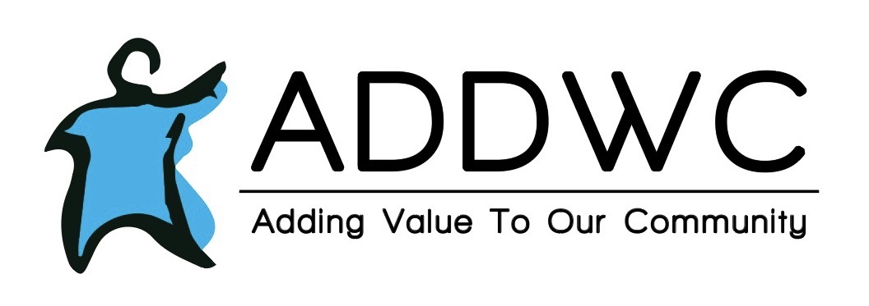

**May 2022**



**RESIDENTIAL**

Now that the weather is getting nicer the CILAS are planning on taking a trip to the farm park to see all the animals. We also plan on planting flowers, and baking homemade cherry cobbler in May. Clients are also looking forward to helping out with the IFF and eating spaghetti.



Anthony “Tony” Harms-5.29

·      **ITALIAN FEAST FUNDRAISER**

   We want to give a huge shout out to all of the individuals and businesses that are supporting ADDWC with monetary donations, and items for the silent auction and raffle. We are getting quite a variety of things! Be sure to come out and check out all of the items and support us at the Italian Feast Fundraiser Saturday, May 14 from 4:30 – 7:00 pm at the Eureka Bible Church. Grab some dinner while you’re there! We are offering delicious spaghetti or alfredo prepared by Michaels Italian Feast. You can dine in, drive through, or carry out.

We are looking for volunteers to donate baked goods to be used for desserts and a bake sale at ADDWC’s 14th Annual Italian Feast Fundraiser. All baked goods can be dropped off at ADDWC on Friday May 13th, 2022 from 7:30am-3:30 pm or at Eureka Bible Church on Saturday May 14th, 2022 between 3:30-4:30pm.



**RECYCLING**

ADDWC recycled over 19 tons of material in February, and over 43 tons in March. This brings our YTD total to over 79 tons of material recycled in the past 90 days!

  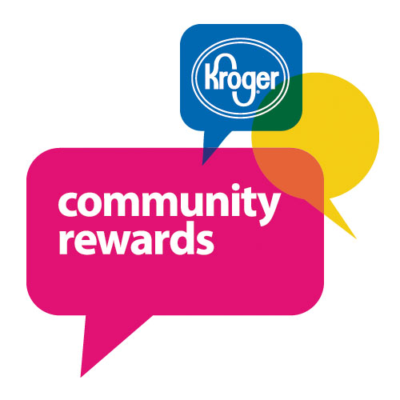 

|  |
| --- |
|  |

Contact Us

Mauries Sugar Shoppe

116 N Main Street

Eureka, IL 61530

(309) 304-1135

**Hours:**

Tuesday-Friday 11:00-5:00

Saturday -11:00-4:00

**Facebook:**

Mauries Facebook

**MAURIES SUGAR SHOPPE**  
Easter was a HUGE success at Maurie's!  Who knew chocolate dipped Peeps could be so good?  Lots of Easter basket candy was sold along with special orders to fill many baskets.

Leaves 'N Beans continues to order treats for its Prospect store.  Cherie, the manager, told me she can't keep our treats in stock!  It's a great partnership!

This month we hosted a Girl Scout Troop of 20 young ladies.  They were most gracious and really enjoyed making "Maurie's style" S'Mores!  They learned about tempering chocolate and making karamel korn in a copper kettle.  We also were excited to host Woodford County Special Education's Life Skills class from Metamora High School!  They had a great time helping make karamel korn and making their Gummy Kabobs.  We were blessed with many SMILES from both groups! In addition to these kiddos, we hosted the Woodford County CEO program for high school seniors.  It stands for Creating Entrepreneurial Opportunities and it is a yearlong class where they visit small businesses and learn about how they started and what it will take for each of them to start their own business.  As part of their "Giving Back Week", they decided to learn more about Maurie's and ADDWC as a non-profit. Each of these students will take what they've learned throughout the year from local businesses and class to build a small business.  They are having a business fair at the Cannery sometime this month to present their businesses.

**LIFE SKILLS HAPPENING**

Life Skills has a lot planned for May!

Life skills will continue to read for our book club in the afternoons followed by watching the movie made from the book. We will be finishing "The Outsiders" and will then start "The Secret Garden".

We continue to utilize Life Skills dollars which clients earn from playing games, and helping out peers. The clients have enjoyed spending their Life Skills dollars at the Life Skills store each month.

Also for the month of May we will be: planning a Cinco De Mayo Celebration, a picnic, tye dying shirts, continuing our small group outings, as well as working on some spring crafts. We are so excited to do more activities outside as the weather gets nicer.

|  |  |
| --- | --- |
| ADDWC Closed Days  May 30th  ________________________________  Contact Us  ADDWC  200 Moody Street  Eureka, IL 61530  (309)467-3015  [www.addwc.org](http://www.addwc.org)  **Facebook:**  ADDWC Facebook | **Employment Opportunities**  Residential DSP - assisting individuals with intellectual disabilities with daily living activities in a residential setting.  2nd and 3rd shifts available  Paid training provided; $15.65(2nd shift), $16.65(3rd shift) after 90-day probation period. |
|  |  |